Results opens with effective statement of overall findings, presents visuals clearly and accurately, presents findings clearly and with sufficient support.

Our mapping algorithm was able to consistently map a given area while navigating around and marking obstacles within the outer frontier. The system was able to look at an initial frontier and find centroids from which it would best be able to continue to map the given area. Using the built in path planning and following functions from GMapping the turtlebot could navigate to the desired point, given that the point is not in an unreachable space. From the starting position the robot can analyze its given area as shown below.

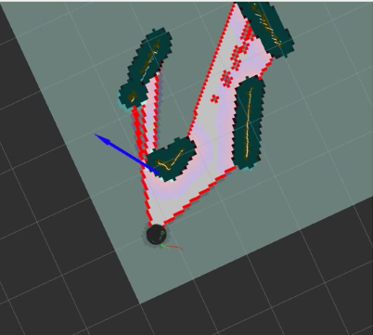

The robot has begun analyze the frontier around it in order to map the area and has planned a waypoint to continue running the mapping algorithm. The robot continues to map utilizing GMapping’s SLAM functions to keep track of its location within the area. Upon encountering and confirming a frontier wall the system adds it to the map and continues on until the frontier is complete and all obstacles are sufficiently mapped. Any gap in the frontier that is large enough for the robot to pass through will be explored, while any gap too small for the robot to pass through will be marked as such on the map. The image below shows the completed map including a fully explored obstacle within the mapped area.

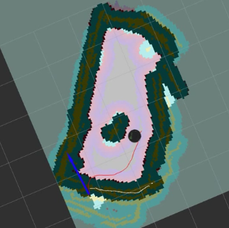

terminal complete.PNG

As shown the robot has completed the outer frontier of the map, and finding no gaps large enough to explore, and finding that all areas within that frontier have been explored and found to have no obstacles it has completed the task of surveying the given area and delivers a message to the user through the terminal to show that the map is complete.

In conclusion throughout the process of completing this final project we have learned how to creating a mapping function for the TurtleBot using GMapping in the ROS environment. The robot was able to complete a 2 dimensional map of a given indoor area by exploring the detected frontier and making decisions on where to explore in the given area. Using a combination of our own code to allow the robot to find points from which to best map the area and the built in code for Path Planning, SLAM and navigation we were able to complete the task of autonomously mapping an area in a short period of time.

Conclusion convincingly describes what has been learned in the lab.